Emotion Recognition Technology using Face Feature Vectors

Jung-Wun Lee, Kyung-Ae Cha, Jeong-Tak Ryu, Se-Hyun Park

Daegu University
201, Daegudae-ro, Jillyang-eup
Gyeongsan-si, Gyeongsangbuk-do, Republic of Korea
wun916@naver.com

Abstract

User authentication services can apply to the face or iris recognition service. So, the interesting in the facial expression technology are growing on various IT convergence field. Facial recognition technology requires a feature vector of facial for emotion recognition, and a high performance learning algorithm. In this paper, we construct a learning system by extracting feature vectors of eyes, mouths and applying a Naive Bayesian classifier to recognize facial expressions. In addition, the experimental results proved the efficiency of the system.

Keywords-component; Facial expressions; Bayesian classifiers; Feature vector; Learning algorithm)

I. Introduction

User authentication technology is mainly focused on face recognition and iris recognition, and the recognition rate is gradually increasing due to the development of smart devices including smart phones and tablets. There have been focused on research to recognize human emotions through stabilized vision-based user authentication technology. This is because emotion recognition is an input medium for interaction between a person and a computer, and nonverbal expressions such as facial expressions, gestures, and gaze are easier to convey meaning than language expressions [1-2]. In addition, it can supplement current face recognition technology such as face tracking and body part detection.
However, emotion recognition has difficulty in correctly recognizing emotions because the degree of expression differs for each person. In order to recognize the correct emotion, learning data should be constructed using data that characterize each emotion, and the emotion is classified by applying a classifier of good performance.
There are many studies to increase the recognition rate, but the processing time and accuracy are still insufficient due to the complicated calculation process[3].
The amount of computation should be reduced through a detection algorithm that can easily detect facial regions sensitive to emotional changes. In addition, it is necessary to study that can improve accuracy without complex calculation process with good performance classifier. In this study, we constructed the learning data by extracting the features of eyes and lips from the human face, implemented the system to recognize facial expressions by applying Naive Bayesian classifier, and proved the efficiency through experimental results.

II. Related Research

In order to recognize human emotions, the detection algorithm extrects feature vector to be used for emotion recognition from the input image, and the learning algorithm classifies the emotion using the detected feature vector.
G. D. Lowe, et. al[4] SIFT (Scale-invariant feature transform) is one of the algorithms used for feature vector detection. It detects objects by extracting information that best represents the characteristics of a particular object.
The algorithm generates a Gaussian Pyramid to detect feature vector candidates for detecting objects such as corner points. The detected feature vector candidates have attributes that are invariant to scale, rotation, and brightness variations.
The algorithm is four or five steps, but performs a complex computation process to detect feature vectors of invariant properties. As a result, the processing speed for object recognition is very slow.
Kim[5] proposed an automated emotion recognition framework by recognizing facial expressions. This framework uses PCA (Principal Component Analysis) to extract facial eigenvectors and recognize human emotions through HMM (Hidden Markov Model) step and posterior probability calculation. Experimental results showed good recognition rate in some facial expressions, but poor performance in other facial expressions.

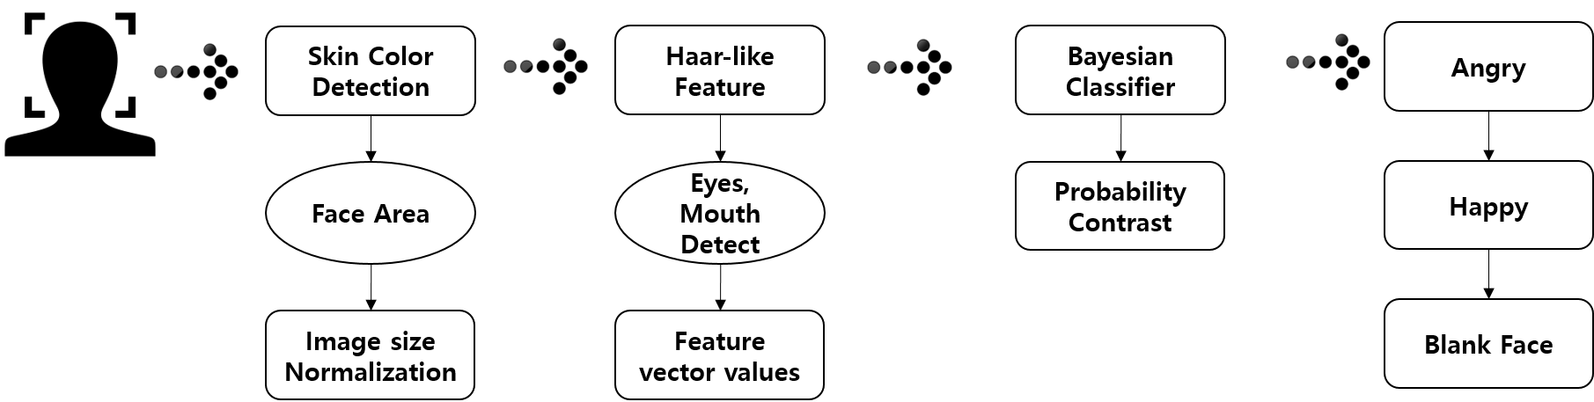
Figure 1. Emotion Recognition Technology using Face Feature Vectors

III. Emotion Recognition Technology using Face Feature Vectors

In order to recognize emotions, this study defined eye and mouth as a feature vector that are sensitive to emotional changes. The extracted feature vectors are classified into human's representative emotions [angry, happy, no expression] by applying the Naive Bayesian classifier. The proposed system is shown in Fig. 1, which consists of feature vector extraction, facial classification, and emotion recognition step.

A. Facial feature vector detection

The input data for recognizing the human emotion is intended to use the data of the human face area. First, a preprocessing process is required to detect an object. This is to obtain the data of the face area by giving a condition recognizable as a face in the input image. The detected face area normalizes the size of the image for learning data construction and comparison operations.
After the normalization, it should be discriminated the facial expression of the detected face. Eyes and mouth shapes are sensitive to changes in emotion. The proposed system defines and classifies three expressions [angry, happy, no expression] using the sensitivity of the face region. In particular, lips respond most sensitively to emotional changes, so it is possible to roughly judge the emotion of the person[6-7]. In this study, the emotion recognition is performed by defining the pixel information of the eye and the mouth area as the feature vector.
Eye and mouth detect feature vectors using Haar-like Feature. The Haar-like Feature basically maintains the geometric information of the object and uses the brightness difference of the area unit, so it can compensate the change of the shape of the object in the region and the slight change of the position to some extent. In this study, eye and mouth of face are detected using Haar-like Feature, and information obtained from each feature vector is applied to beige classifier to classify three facial expressions.

B. Facial Expression classification

If feature vectors are extracted, facial feature vectors are applied to Naive Bayesian classifiers[8] to classify facial expressions. Naive Bayesian classifier is a mathematical theorem about conditional probability. The Bayes theorem represents the relationship between the prior probability and the posterior probability of a random variable, and Naive Bayesian classifier is a kind of probabilistic classifier that applies the premise that if the properties are independent of each other in Bayesian theorem.
The input values of the Naive Bayesian classifier use eye and mouth data extracted with Haar-like feature. The horizontal component of the detected mouth is defined as $X1$, and the vertical component between the two lips is defined as $Y_{1}$. The vertical component between eye and mouth is defined as $Y_{2}$, and finally the area of mouth is defined as area. The feature vector $X=(X1,Y_{1},Y_{2},\text{Area})$ which summarizes the four data.
The facial expression defines classes (C0, C1, C2) for [angry, happy, no expression], and discriminates the appropriate expression for the input image. When the feature vector $X=(X1,Y_{1},Y_{2},\text{Area})$ is present, the Bayes theorem for facial expression classification can be defined as Equation (1).

$\begin{aligned}P(C_{i}|X)=\frac{P(C_{i})P(X|C_{i})}{P(X)} \\ (C_{0}=\text{angry},C_{1}=\text{happy},C_{2}=\text{no}\text{_exp}\text{ression})\end{aligned}$ (1)

In Equation (1), we find the likelihood $P(X|C_{i})$ which has the highest probability of $X$, and classify the facial expression as $C_{i}$. At this time, $P(X)$ can be omitted because it is the normalize value. Therefore, Bayesian classification equation for facial expression classification can be defined as Equation (2).

$C_{\text{MAP}}=\text{argmax}P(X|C_{i})P(C_{i})$ (2)

In this study, we used 480 images of [Angry, Happiness, Expressionless] as the learning data for the facial expression classification, and we prove the efficiency of the Bayesian classifier through experiments.

IV. Experiment

In this study, we apply facial feature vector which is sensitive to emotion change to Naive Bayesian classifier for recognize facial expression. We conducted experiments to demonstrate the efficiency of the proposed system. The database of facial expression images used in the experiment is shown in Fig.2. It consists of JAFFE (Japanese Female Facial Expression)[9], KDEF (Karolinska Directed Emotional Faces)[10] and FEI Face Database[11]. In this study, each database is the frontal face of a man and a woman of white and yellow and black, and each person did not wear glasses.

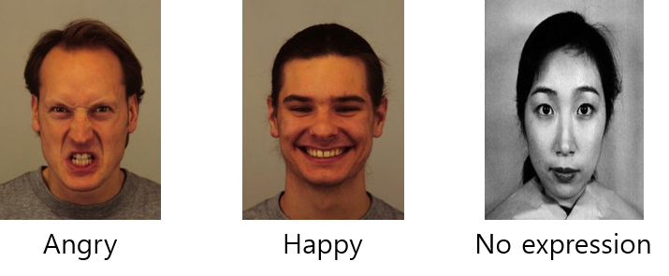
Figure 2 Exaple Images from [9],[10]

Experiments to demonstrate the efficiency of the proposed system are described. There are described experiments to demonstrate the efficiency of the proposed system
First, the face database to be used in the experiment is 600 images, and 480 face images are used as training data. The Haar-like feature was used to obtain feature vectors for the vertical and horizontal components of the mouth, the area, and the distance between the eyes and mouth. The remaining 120 facial images were used as test data.
We analyzed the characteristics of the feature vectors to verify the validity of the feature vectors. The mouth area of ​​[angry] and [no expression] has a similar range of values. However, [no expression] can distinguish expression because the distance between eyes is larger than [angry]. [happy] has a different range of values ​​from the other two expressions. As a result, facial classification is done well.
Next, we use the face image of the general person, not the image in the database. The subjects were 10 persons without prior knowledge. For face recognition, the input image is subjected to face detection and feature vector extraction.
The experimental results are shown in Table 1. Experimental results showed average recognition rate of 90%. [happy] is the most characteristic expression, recognition rate is 100%. [no expression] has a constant change of facial expression, and the recognition rate is 90%. Finally, the recognition rate of [angry] is 80%, which is lower than other expressions.

Table 1. Facial recognition result judged by real person image

Classify  real | Anrgy | Happy | No expression | Precision
Angry | 8 | 0 | 2 | 80%
Happy | 0 | 10 | 0 | 100%
No expression | 1 | 0 | 9 | 90%

V. Conclusion

In this study, we proposed a technique to recognize human emotions by applying the feature of facial region that is sensitive to facial expressions and applying it to Naive Bayesian classifier, one of learning models.
We applied a Bayesian classifier to the information about eyes and lips detected from the face, and confirmed that it has a good facial recognition rate by a relatively simple calculation process. It is expected to be able to quickly and accurately classify user's perception and emotion in various areas requiring real-time analysis.
The future goal is research on the development of responsive contents industry technology that reflects the industrial needs to grasp the change of emotions about the environment that is used in mobile devices and so on, and to positively influence emotions that users take unconsciously.

Acknowledgment

This study is the result of the research project of cooperation technology development supported by SMBA in 2017 (Industry-University Cooperative Technology Development Project (Research Village), Project Number: C0483177).

References

[1] J. S. Lee, and D. H. Shin, “A study on the enhancement of emotion recognition through facial expression detection in user's tendency,” Journal of the science of Emotion & sensibility, Vol. 17, No. 1, pp. 53-62, 2014.
- G. M. Heo, and S. M. Gang, “Facial expression recognition technology,” Institute of Control, Robotics and Ststems
- H. J. Woo, “A FacialComponentsExtraction Using thePCA and Templatematching forFacialExpressionsRecognition,” Journal of the Korea Contents Association, Vol. 14, No. 11, pp. 7-15, 2014.
- P. Viola, and M.J. Jones, “Robust Real-Time Face Detection,” International Journal of Computer Vision, Vol. 57, No. 2, pp. 137-154, 2004.
- J. O. Kim, “A Recognition Framework for Facial Expression by Expression HMM and Posterior Probabiliy,” Journal of KISS : Computing practices, Vol. 11, no. 3, pp. 284-291, 2005
- Y. I. Kim, D. J. Kim, K. H. Hong, and S. J. Cho, “Facial Expression Feature Extraction for Expression Recognition,” Proceedings of the Institute of Electronics and Information Engineers, pp. 537-540, 2005.
- A. Nikolaidis, and I. Pitas “Facial feature extraction and pose determination,” Journal of Pattern Recognition, Vol. 33, No. 11, pp. 1783-1791, 2000.
- W. J. Kim, K. B. Lee, and M.G. Kim, “An Implementation of Pan-So-Ri Classification Program Using Naive Bayesian Classifier,” Journal of the Institute of Internet Broadcasting and Communication, Vol. 11, No. 3, pp. 153-159, 2011
- The Japanese Female Facial Expression, “http://www.kasrl.org/jaffe.html”
- Karolinska Directed Emotional Faces, “http://www.emotionlab.se/resources/kdef”
- Thomaz, Carlos Eduardo. FEI face database. “http://fei. edu. br/~cet/facedatabase.html”

